Technical Documentation: Automated Employee Time-Off Management System

1. Introduction
This documentation describes the Automated Employee Time-Off Management System, designed using Airtable and Zapier.
The goal of this system is to:
- Allow employees to submit leave requests online.
- Enable managers to approve or reject requests.
- Automatically update employee leave balances when requests are approved.
- Reset leave balances annually to ensure fair and consistent tracking.
By combining Airtable’s relational database features with Zapier’s automation, the system reduces manual work, prevents errors, and improves transparency for both managers and employees.

2. Airtable Database Structure
The system uses three main Airtable tables: Employees, Managers, and Leave Requests. These tables are linked together to form relationships that power automation and reporting.

2.1 Employees Table
The Employees table stores information about each employee, including their manager, role, and leave balance.

Fields:
- Name – Single line text (employee’s full name).
- Employee ID – Autonumber (unique identifier for each employee).
- Email – Email field (used for notifications).
- Manager – Linked record (connection to the Managers table).
- Name (from Managers) – Lookup (brings in manager’s name automatically).
- Manager Email – Lookup (brings in manager’s email).
- Department – Single line text (department the employee belongs to).
- Role – Single line text (employee’s job role).
- Approved Leave Days – Number field (tracks the total approved leave days; updated via automation).
- Employee PTO Leave Balance – Number field (tracks remaining PTO balance; updated via automation).
- Approved PTO Leave Days – Rollup field (sums up the total approved leave days from the Leave Requests table).
Employee Leave Balance – Formula field:
22 - {Approved PTO Leave Days}
- This ensures that each employee starts the year with 22 days of leave entitlement, and the balance is reduced as requests are approved.

2.2 Managers Table
This table stores all manager records and connects them to employees.
Fields:
- Name → Single line text.
- Manager ID → Autonumber (unique for each manager).
- Email → Email field (used for workflow notifications).
- Department → Single line text.
- Employees → Linked to the Employees table. Shows all employees reporting to that manager.
Purpose: Keeps a clear record of managers and allows automated workflows to pull their email when a request is submitted.

2.3 Leave Requests Table
This table is where employees submit leave requests and managers review them.
Core fields:
- Request ID → Autonumber.
- Employees → Link to Employees table.
- Manager (from Employees) → Lookup (manager’s name).
- Manager Email (from Employees) → Lookup (manager’s email).
- Start Date / End Date → Date fields.
- Number of Days Requested → Formula:
WORKDAY_DIFF({Start Date}, {End Date})

- Status → Single select (Pending, Approved, Rejected).
- Notes → Long text (employee comments).
- Manager’s Comments → Long text (feedback or reason).
These fields below extend functionality for automation, tracking, and reporting:
- Created Time → Automatically records when the request was made.
- Last Modified Time → Tracks the last update to the record (important for Zapier triggers).
- Name (from Employees) → Lookup (shows the employee’s name).
- Name (from Manager) (from Employees) → Lookup (shows the manager’s name for clarity).
- Employee Email → Lookup (used to notify the employee of approval/rejection).
Formulas & Calculations
- PTO Leave Balance → Formula:
22 - {Number of Days Requested}
(Shows hypothetical balance if this request is approved, without changing the actual employee record yet.)
- Current Year → Formula:
YEAR({Start Date}) = YEAR(TODAY())
(Checks if the request falls in the current year for filtering reports.)
- Record Link → Formula that generates a direct link to the request’s Kanban view (sent to managers in email notifications).
Rollups / Lookups from Employee Table
- Approved PTO Leave Days → Lookup from the Employees table to show how many days are already approved.
- Approved Leave Balance → Lookup from the Employees table to display remaining leave balance.

With this setup, the Leave Requests Table not only tracks requests but also powers automation (notifications, updates, balance deductions, and reporting).

3. Airtable Automations
Airtable was configured with two main automations to reduce manual work and ensure data accuracy:

3.1 Automation 1: Update Employee Record on Approval
- Trigger: When a record in Leave Requests changes and Status = Approved.
- Actions:
  - Update Record: The Name (from Employee) field linked to the leave request table is used to update the leave balance and approved leave days of the employee who submitted the request.
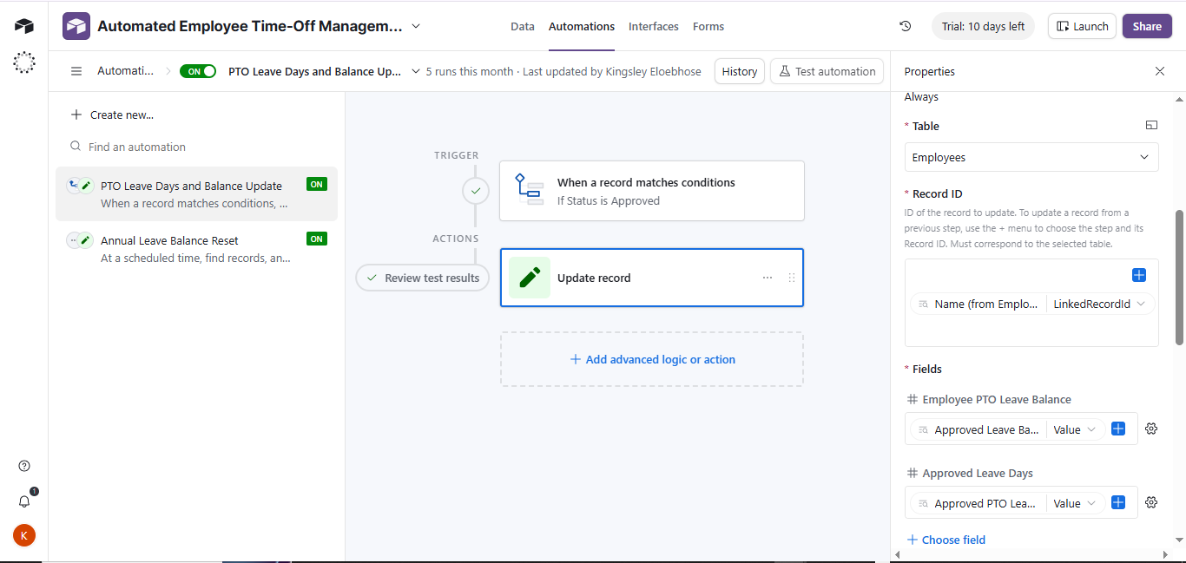

3.2 Automation 2: Annual Leave Reset
- Trigger: Runs January 1st every year (scheduled time).
- Actions:
  - Find all Employee records.
  - Update each record:
    - Reset Approved Leave Days to 0.
    - Reset Employee PTO Leave Balance to 22.
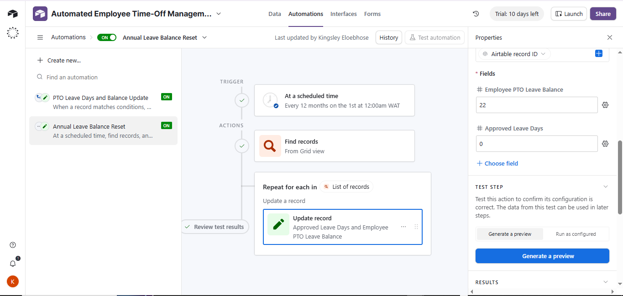

Together, these automations ensure that balances update immediately when requests are approved, and every employee starts the year with a fresh balance.

4. Zapier Automations
Three Zaps were created to handle notifications and status updates:

Zap 1: Notify Manager of New PTO Request
- Trigger: New record in the Pending Requests view (Leave Requests table).
- Action: Send email to the employee’s manager.
  - Email includes request details: employee name, start date, end date, number of days requested, notes.
  - Email also includes a Kanban View link so the manager can review and approve/reject directly in Airtable.

Zap 2: Notify Employee of Approved Request
- Trigger: Record enters the Approved Requests view (Leave Requests table).
- Action: Send email to the employee (with manager copied).
  - Email includes approval confirmation, dates, number of days approved, and updated leave balance.

Zap 3: Notify Employee of Rejected Request
- Trigger: Record enters the Rejected Requests view (Leave Requests table).
- Action: Send email to the employee (with manager copied).
  - Email includes rejection notice, dates requested, and manager’s comments if provided.

5. Summary of Workflow
- Employee submits request → Airtable form logs it in the Leave Requests table with status = Pending.
- Manager notified → Zap 1 sends email with details and Kanban view link.
- Manager decision → Approves or rejects in Airtable.
- Airtable automation updates balances when the status changes to Approved.
- Zapier notifies the employee:
  - Zap 2 (Approved).
  - Zap 3 (Rejected).
- Annual Reset → Airtable automation resets all balances to 22 days every January 1.

